Project Sponsor: Burns Paiute Tribe
Subbasin: Malheur River Subbasin
Province: Mid Snake
Project Title: Evaluate the Life History of Native Salmonids in the Malheur River Subbasin
Project Number: 199701900

ISRP Comment: How has information been used and how it has influenced the direction of the current proposed work.

This project is a cooperative effort between the Oregon Department of Fish and Wildlife, US Bureau of Reclamation, US Bureau of Land Management, US Fish and Wildlife Service, and US Forest Service. Data collection and design are discussed annually with these project cooperators. Project results and data are provided to the partners and any fishery management changes are implemented according to the direct authorities of the particular entity. It is evident this current project has provided critical information for defensible land and fish management decisions and examples are provided as follows:

US Bureau of Reclamation – Results generated by the current project were imperative to the development of the US Fish and Wildlife Service Biological Opinion for Bureau of Reclamation Operations and Maintenance in the Snake River Basin Above Brownlee Reservoir (USFWS 2005). The Biological Opinion identifies detailed, non-discretionary actions in the Terms and Conditions that the Reclamation needs to adhere to. The terms of the Biological Opinion was developed from existing data, including those results from the current project.

The current project documented bull trout entrainment rate of 12% through the spill operations at Agency Valley Dam (Schwabe et al. 1999). This data was utilized to develop the condition 4.d in the Biological Opinion to continue existing efforts to trap and return bull trout that are entrained at Agency Valley Dam back to Beulah Reservoir or the North Fork Malheur River upstream of the dam. The Tribe has contracted directly with the US Bureau of Reclamation in 2005 and 2006 and has transported 0 and 7 adult bull trout respectively. With only 63 bull trout redds observed in the North Fork watershed in 2005, the transportation of these fish is critical for the local population.

The current project documented significant declines of fish populations in 2002, 2003 and 2004 compared to 1998 and 1999, including the number of bull trout utilizing the reservoir for winter rearing. Local fish managers were concerned that extreme low reservoir levels impact the population of the resident prey base in the reservoir. The identified decrease in fish numbers and the potential impact to the prey base of bull trout led to the development of term 4.a, 4.b, and 4.c in the USBR Biological Opinion that directs the Reclamation to research and identify minimum pool volumes for prey species, supplement prey source in years where drawdown levels are below a level sufficient to maintain habitat for bull trout prey, and identify and implement other mitigation strategies.

The current project has documented fluvial bull trout utilizing the mainstem Malheur River as winter rearing habitat from Logan Valley downstream to RK 268 through radio telemetry studies (Schwabe el al 2001; 2002) . A large diversion structure is located on the Malheur River at RK 259 and the head of Warm Springs Pool is located at RK 209. It is possible that fish forage as far downstream as Warm Springs Reservoir during winter, although bull trout have not been documented in Warm Springs Reservoir. Due to the lack of evidence of the presence of bull trout, changes in the operation of Warm Springs Dam to protect bull trout under the current Biological Opinion were not warranted. The US Fish and Wildlife Service Bull Trout Recovery Plan identify core recovery habitat on the Malheur River from the headwaters downstream to Namorf Dam (RK 107). The current project seeks to gain knowledge of native fish that lead to defensible fish management decisions which in this case was unable to change dam operations given the scientific data collected.

Oregon Department of Fish and Wildlife – Angling regulations were changed in the Malheur River above Warm Springs Reservoir and in the North Fork Malheur Reservoir to fly and artificial lure only after laboratory analysis suggested that two radio tagged bull trout that perished in the North Fork Malheur River was caused from angling.

Radio telemetry data suggested associated potential diversion loss with an unscreened diversion on the North Fork Malheur River above Beulah Reservoir. ODFW has approached the landowner and recently installed a fish screen to prevent any future diversion loss.

US Forest Service – Adult radio telemetry study was used to determine migratory movements and critical spawning areas in the both the upper North Fork Malheur River and upper Malheur River local populations. In 1999, cattle grazing regulations changed to conclude by August 15 on all bull trout critical spawning areas. In the North Fork system, allotment use shifted from cattle grazing to sheep grazing in Elk Creek, Sheep Creek and Swamp Creek to minimize the effect on rearing juvenile bull trout. In addition, undersized culverts were replaced on Forest Road 16 to improve migratory bull trout passage into critical spawning habitat on Little Crane Creek. In the upper Malheur, an undersized culvert was replaced in 2005 by a bridge to improve migratory bull trout into Meadow Fork Creek, a stronghold drainage for bull trout and critical spawning area for the local population.

Burns Paiute Tribe – The current project has been collecting data to identify actions that shall provide fisheries benefits to the ongoing wildlife projects, Logan Valley Wildlife Mitigation Site project no. 200000900, and Malheur River Wildlife Mitigation Site project no. 200002700. The current project has developed a monitoring protocol for fish habitat utilization on both properties. Monitoring protocols have been included in FY 2004 annual reports (Schwabe et al. 2005), and is on file in the department and available on the Bonneville Power Administration website. A habitat assessment has identified specific restoration activities at the Logan Valley site. In 2004, 3200 willow cuttings were planted on 1 km of lower Lake Creek and a bridge constructed replacing a ford crossing on Lake Creek through a grant from the US Fish and Wildlife Service Landowner Incentive Program.

Current activity – The past and current habitat and telemetry assessments are driving restoration activities on the wildlife mitigation lands for fisheries resources. For the Logan Valley Wildlife Mitigation Site, several diversions are of concern associated with the property and diversion loss is a high risk. Staff recently have been awarded a grant in April 2006 through the Oregon Department Fish and Wildlife and US Fish and Wildlife Service to install water control devices and fish screens on diversions located on the property. This work is scheduled to be completed this year. Past habitat and telemetry studies on Big Creek suggest little habitat diversity and cover resulting in minimal rearing and holding habitat for bull trout on lower sections of the creek (Schwabe et al. 2001). In the next cycle, the wildlife project proposes to focus on restoring riparian conditions in Lake Creek. Passive restoration practices on Big Creek have resulted in a slow but progressive expansion of the willow community and growth (Boyd et al. 2005). The Tribe is considering constructing a nursery where large quantities of localized stock of hardwoods can be produced. With excess plants, willows may be planted on Big Creek to accelerate the recovery of the riparian and aquatic habitats.

For the Malheur River Mitigation Site, crews are currently assessing habitat conditions on numerous tributaries. A diversion dam and unscreened ditch have been identified as a fisheries concern (Fenton et al. 2006). Staff recently have been awarded a grant in April 2006 through the Oregon Department Fish and Wildlife and US Fish and Wildlife Service to install a fish friendly diversion structure and a complex electrical fish screen. The current project has identified that hay grass fields extend into the floodplain of the Malheur River (Fenton et al. 2006). The fisheries personnel recommend expanding from riparian strips to more riparian floodplain restoration. Staff is currently in the process of enrolling the Malheur River into the CREP program that shall provide a streamside buffer of 180 feet that will result in pushing back much of the hay grass meadows. Crews will continue to collect stream data in 2006 and identify reaches of perennial water, isolated fish populations, spring water sources and overall habitat quality and quantity.

The Tribe is currently involved with determining the genetic impact brook trout has on the upper Malheur River bull trout population. The Tribe has been an advocate to remove exotic species but have noted some resistance or concern from the public. The Tribe has confirmed that hybridization and introgression between the two species has occurred and is currently determining if such interactions are random or selective. These findings will be published and shall provide the scientific information needed to determine the direction of future eradication efforts.

Lastly, the project is currently assessing the genetic makeup of bull trout in the core area. Genetic information on local populations within the core area is necessary for a more complete understanding of bull trout interactions and population dynamics, and may lead to revision of recovery criteria. Due to the depressed number of individuals, genetic analysis will also determine the occurrence of a current or past genetic bottleneck so management can assess the conservation value of the remaining fish. These finding will be published in a professional journal.

The US Forest Service and the Tribe have discussed the possibility of developing a partnership that shall focus on the restoration of fish habitat. Recovery actions identified include riparian protection and cattle exclusion from steams in the Logan Valley area. Project proposal no. 200712000 titled Malheur Subbasin Habitat Restoration and Fish Enhancement – Logan Valley Project seek to accommodate priority restoration stream reaches in Logan Valley and combine resources to economically restore aquatic habitats. Funding of project no. 200712000 will enable the Tribe to actively engage in fisheries on-ground restoration activities and implement the needs identified through the current ongoing assessment proposal.

Fish population and Habitat Response – The ISRP is inquiring on specific fish population and habitat data and its change over time as a result of project actions. Currently, the only fish population monitoring information that reflects any change over time is the bull trout spawning redd counts. Spawning counts are conducted on all streams with known or suspected spawning bull trout (Fenton et al. 2006). The North Fork Malheur population of spawning bull trout had good counts from 1999 to 2002 (Figure 1). Assuming that below average annual participation in the Subbasin since 2001 had no effect on bull trout survival, the bull trout spawning population can be considered stable at best.

Figure 1 – The number bull trout redds observed in the North Fork Malheur River watershed from 1996 – 2005.

Bull trout redd counts conducted in the upper Malheur River population are illustrated in figure 2. Redd counts peak in 2001 with decrease to extreme low number in 2003. Staff reported a 77% decline in salmonids population due to a flash flood that occurred on July 26, 2003 (Schwabe et al. 2004). This decline is also reflective in the redd counts in the upper Malheur in 2003.
Figure 2 – The number of redds observed in the upper Malheur River watershed, 1998-2005. The counts include redd counts prior to September 15 to avoid counting brook trout redds. ODFW has determine a bimodal frequency of redds, the first peak occurring prior to September 15 and the second peak in October.

The current fish monitoring activities in the Malheur River Subbasin is species and age class specific and limited in nature. Redd counts have been criticized by fish managers in the past as a tool to assess bull trout populations. The information is good, baseline, economical based monitoring for bull trout trend but to determine fish population response to management actions, additional monitoring is required. Due to these limitations, the future direction of the current proposed work is to sample 180 sites throughout the Malheur River Subbasin. Sites will be randomly generated utilizing the E-MAP protocol. A two-four pass 50% reduction population assessment will be conducted at each site to determine fish density. All 180 sites will be sampled in 2007 and will be considered as reference condition.

In our past habitat assessments on Lake and Big Creeks, staff had made recommendations to the Tribal wildlife managers on project no. 200000900, Logan Valley Wildlife Mitigation Site to exclude grazing from the riparian and plant willow (Salix spp.) within the floodplain to promote riparian recovery. In spring 2004, the Tribe received a grant from the US Fish and Wildlife Service Landowner Incentive Program to plant 3,500 plants along the lower 1 km of Lake Creek (BPT 2004). Photopoint stations were determined and are scheduled to be revisited in 2006 (Figure 3, 4, 5). A site visit in fall of 2004 reported a survival rate of 15%. Cattle grazing have been excluded from the riparian since 2000.

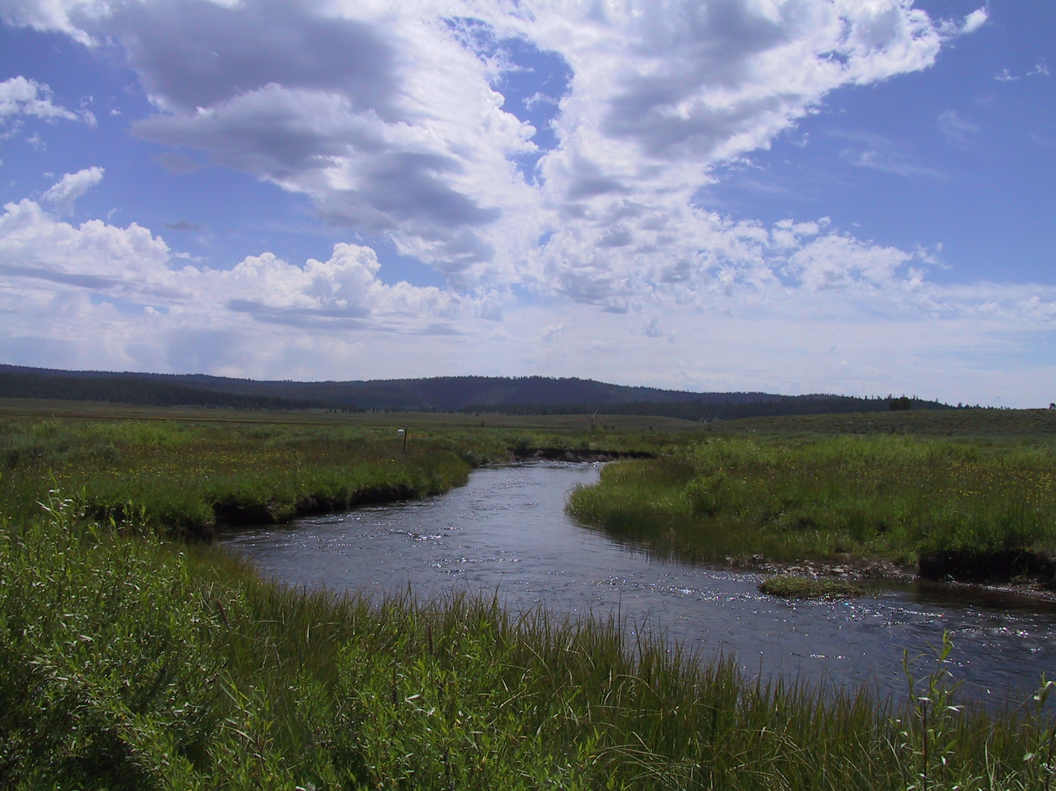
Figure 3 - Photo Site #1 Willow Recovery Project. June 18, 2004

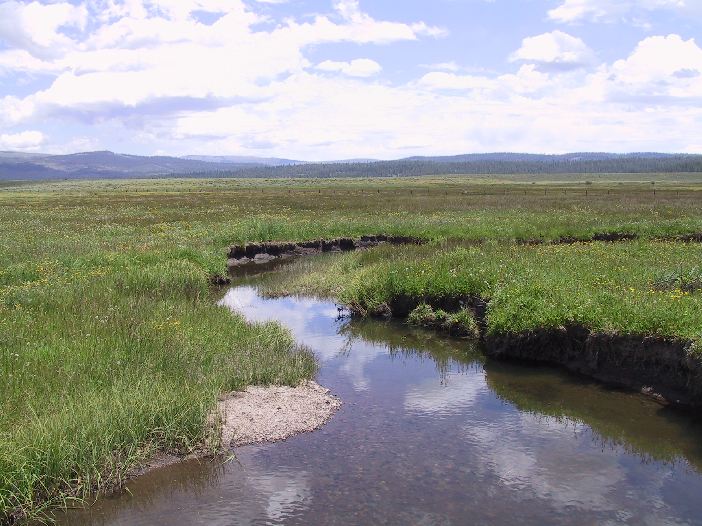
Figure 4 - Photo Site #2 Willow Recovery Project. June 18, 2004

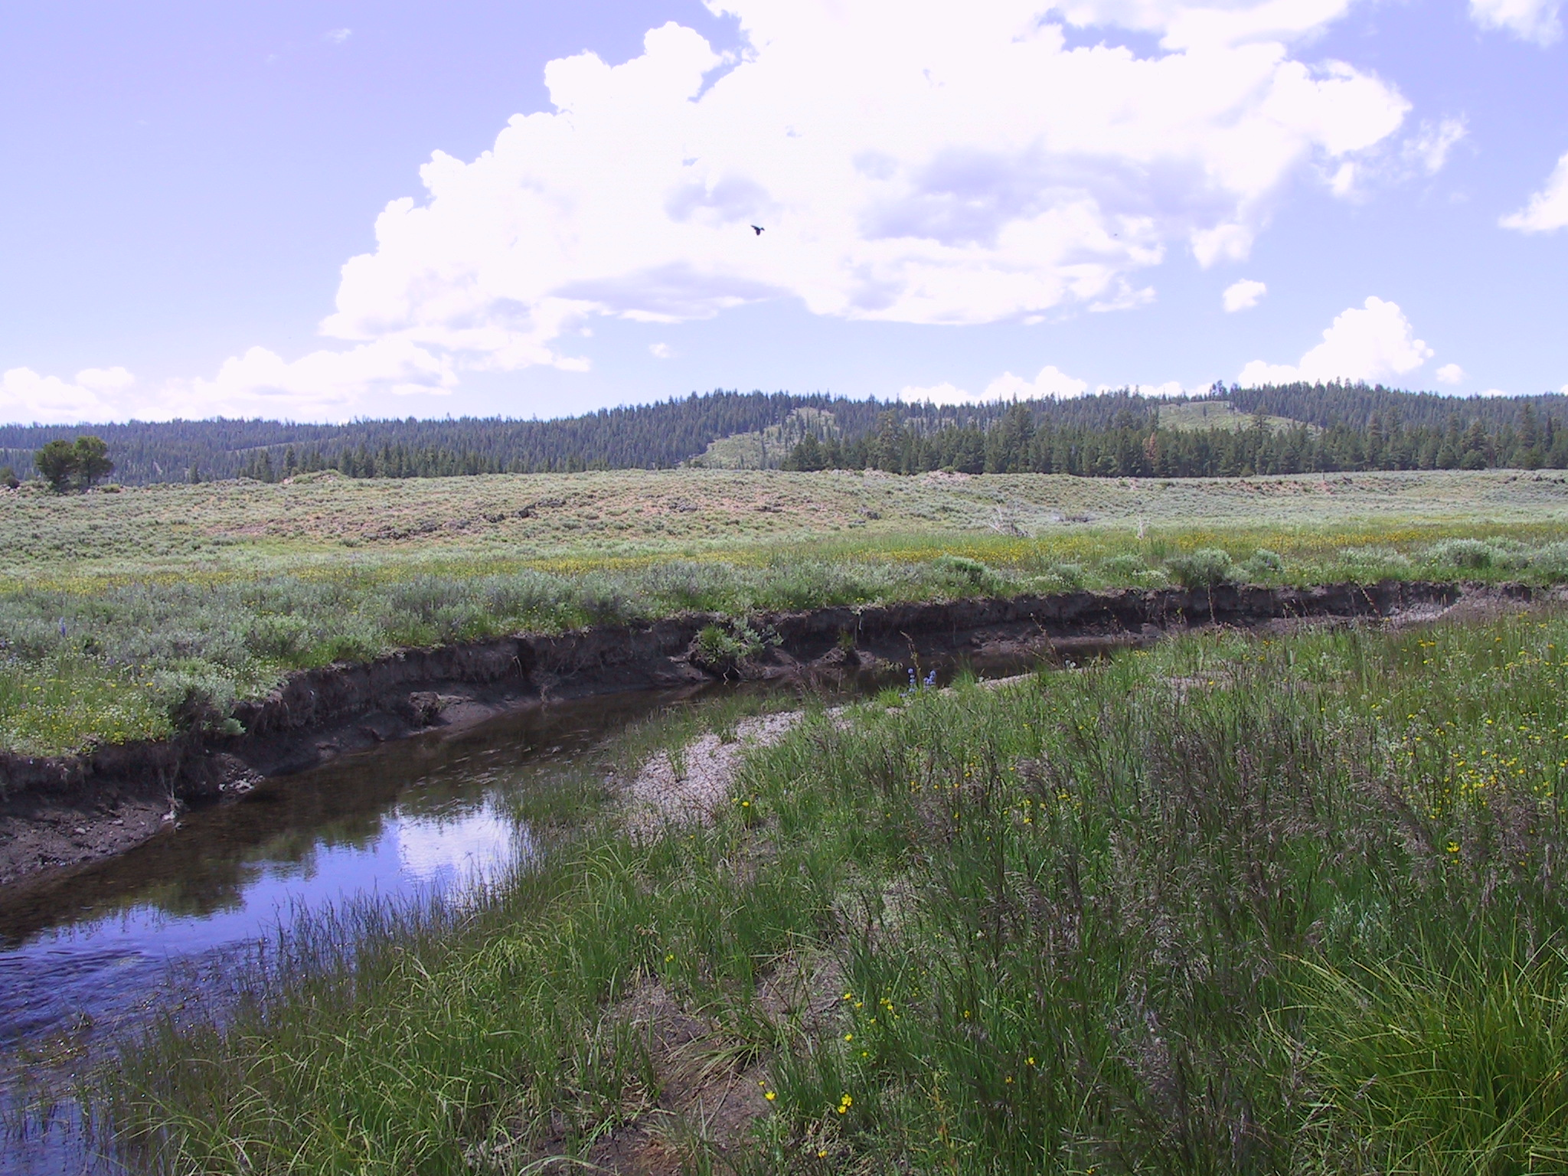
Figure 5 - Photo Site #3 Willow Recovery Project. June 18, 2004

Given the current priorities, Tribal management has opted to promote passive restoration and cattle exclusion on Big Creek to achieve riparian restoration goals. Boyd and Zamora (2005) quantified woody biomass increases of willow communities on Big Creek through photo monitoring using a digitized visual obstruction technique (Boyd and Svejcar 2005). All willow communities showed increases in spatial area as compared to year 2000 values (Figure 6). Light to moderate browsing, primarily associated with elk, appears to be limiting increase of willow biomass at the lower three monitoring sites of Big Creek (Site 1a, 1b and 1c).

Base water quality parameters will be taken such as: 1) begin and end stream and air temperature, 2) conductivity measurement. Channel measurement that includes bankfull width/depth and floodplain widths will be taken to determine Rosgen stream classification. Lastly, detailed habitat unit measurement will be taken using ODFW stream survey protocols.
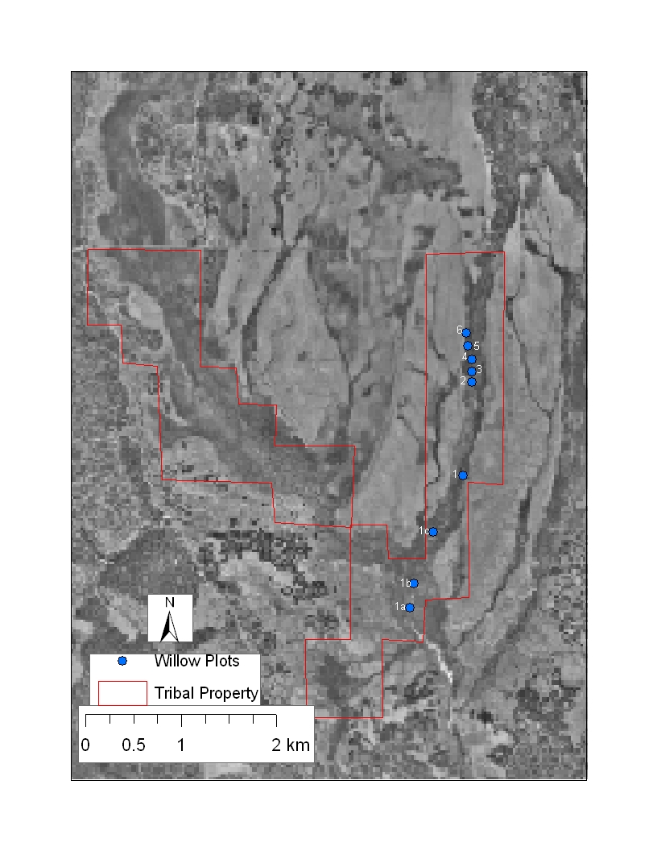
Figure 6 – Overview of willow monitoring sites in Logan Valley.

Site #1A

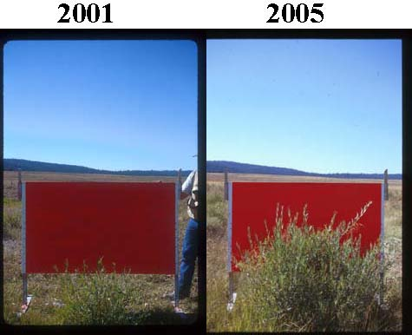

Visible
Year Pixels*
2001 108180
2002 106636
2003 95964
2005 68535
* Decreasing visible pixels indicates increasing willow biomass.

2001
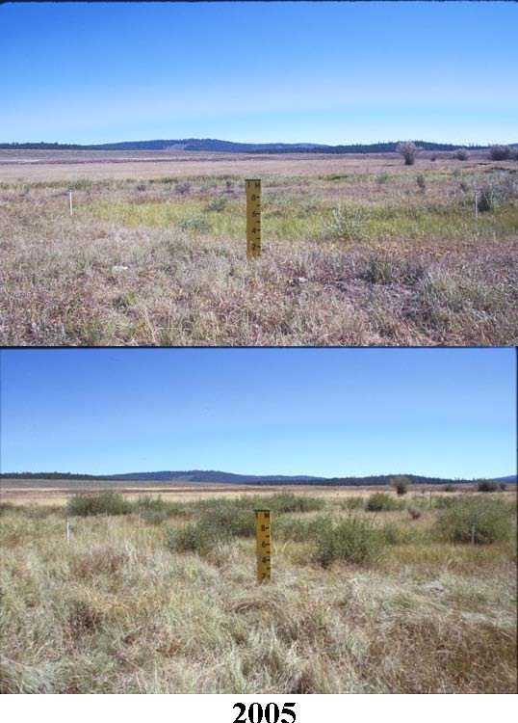
Site #1B

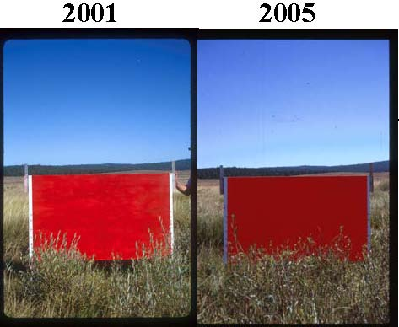

Visible
Year Pixels*
2001 90856
2002 95020
2003 103341
2005 90000
* Decreasing visible pixels indicates increasing willow biomass.

2001
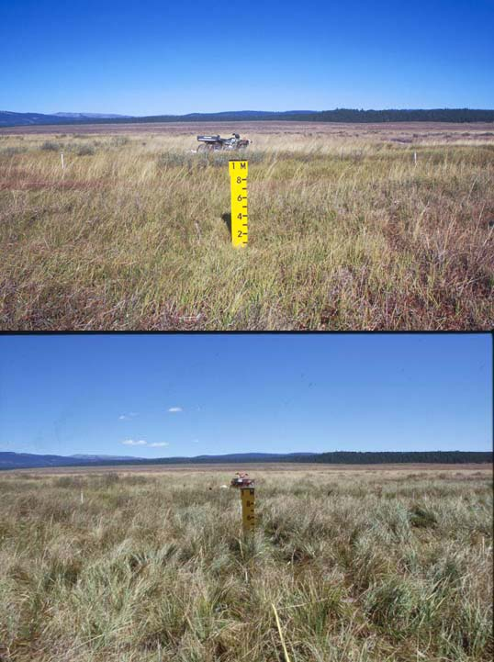
2005
Site #1C
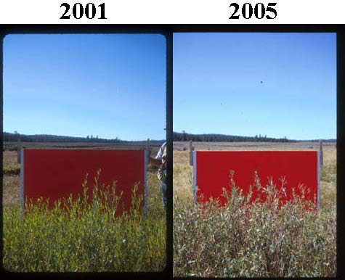

Visible
Year Pixels*
2001 79875
2002 93330
2003 90057
2005 64703
* Decreasing visible pixels indicates increasing willow biomass.

2001
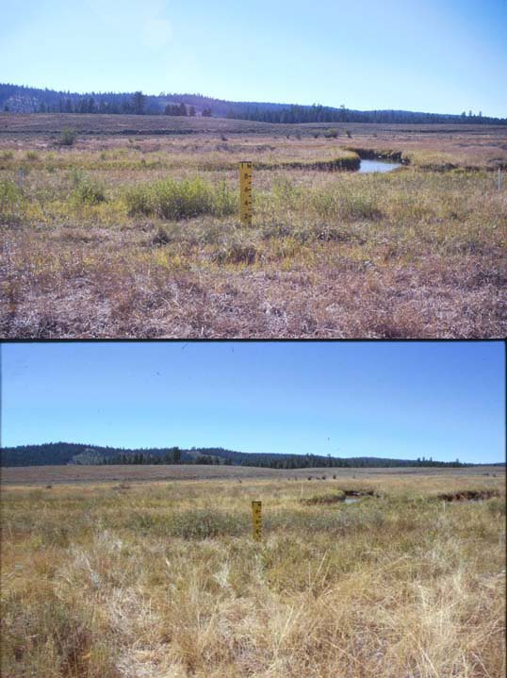
2005
Site #1
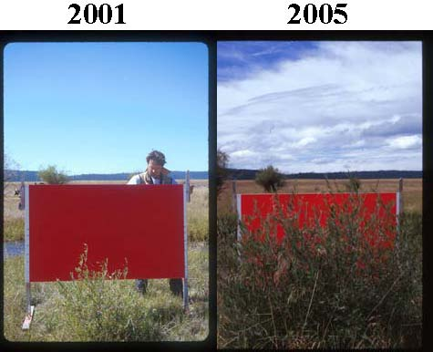
Year Visible Pixels*
2001 104113
2002 93436
2003 69934
2005 29028

* Decreasing visible pixels indicates increasing
willow biomass.

2000
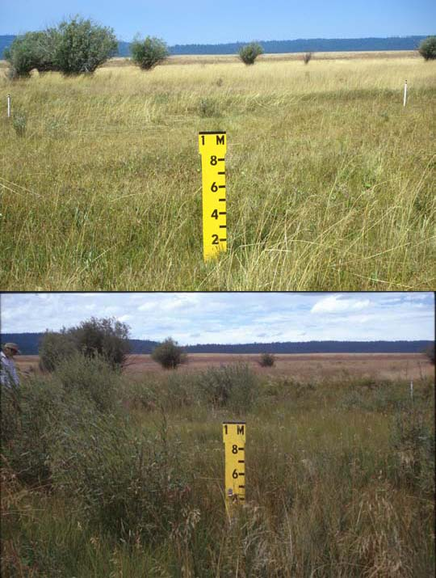
Willow
Year | Area (cm2)
2000 | 11486.4
2001 | 20144.0
2002 | 25369.1
2003 | 56003.1
2005 | NO DATA

2005

Site #2

Year Visible Pixels*
2001 10078
2002 9718
2003 1139
2005 2722
* Decreasing visible pixels indicates
increasing willow biomass.

2000
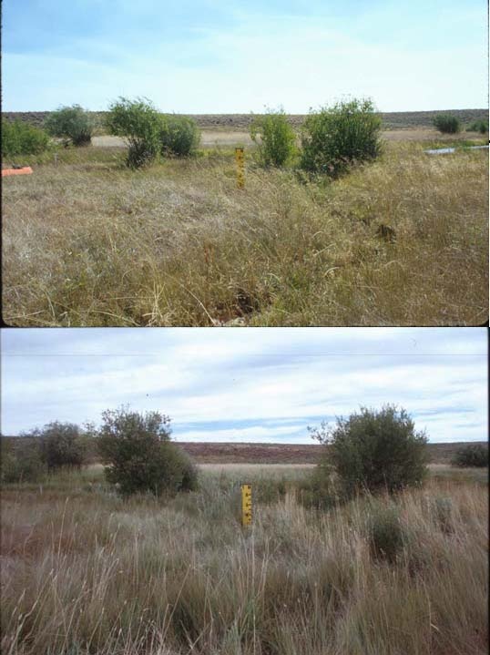
Year Willow Area (cm2)
2000 231415.2
2001 253689.5
2002 188381.3
2003 317002.1
2005 274535.6

2005
Site #3

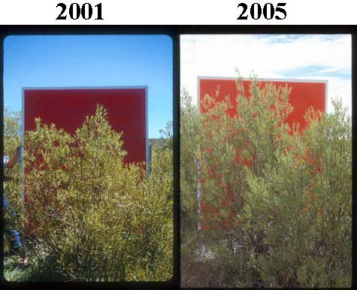
Year Visible Pixels*
2001 82300
2002 78790
2003 NO DATA
2005 43187
* Decreasing visible pixels indicates increasing willow biomass.

2000
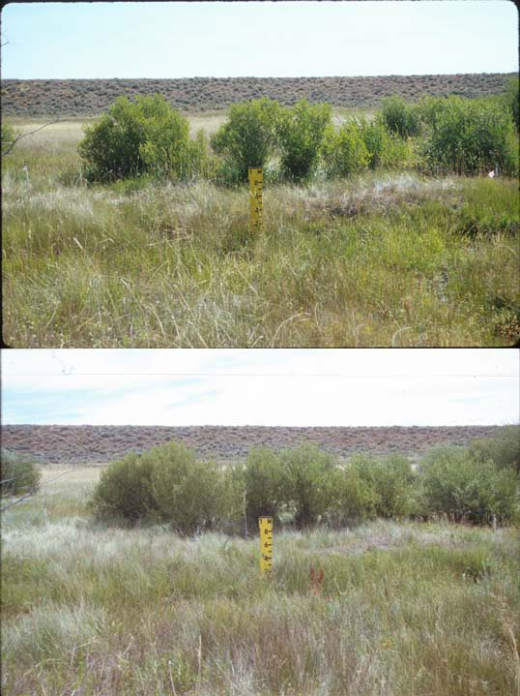
Willow
Year | Area (cm2)
2000 | 138257.7
2001 | 152767.9
2002 | 154096.2
2003 | NO DATA
2005 | 149997.1

2005

Site #4
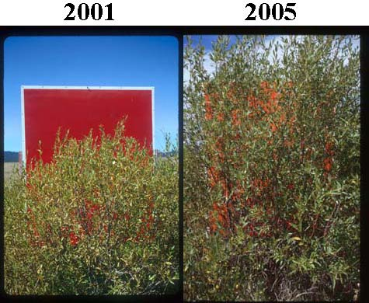
Year Visible Pixels*
2001 82312
2002 69585
2003 36188
2005 26795
* Decreasing visible pixels indicates increasing willow biomass.

2000
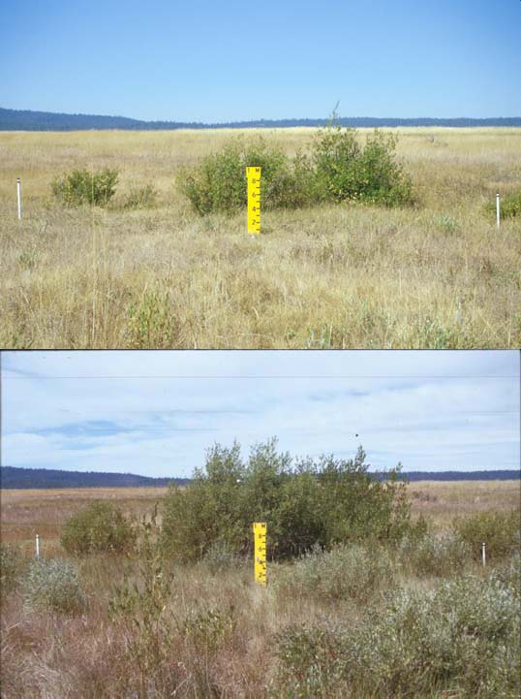
Willow
Year | Area (cm2)
2000 | 66927.7
2001 | 71491.9
2002 | 69546.4
2003 | 93447.7
2005 | 109653.1

2005
Site #5

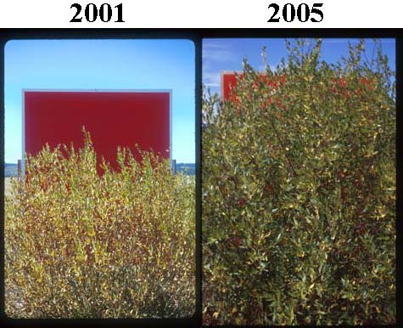
Year Visible Pixels*
2001 98798
2002 78497
2003 32377
2005 11505
* Decreasing visible pixels indicates increasing
willow biomass.

2000
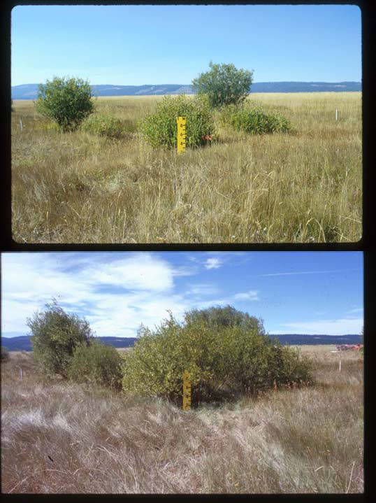
Willow
Year | Area (cm2)
2000 | 215849.9
2001 | 238327.0
2002 | 283675.0
2003 | 346692.4
2005 | 371122.5

2005
Site #6

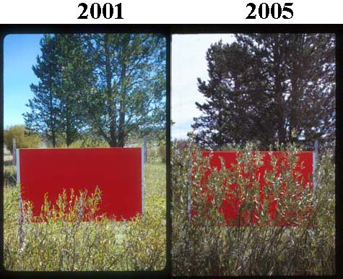
Year Visible Pixels*
2001 88219
2002 64973
2003 68246
2005 36545
* Decreasing visible pixels indicates increasing
willow biomass.

2000
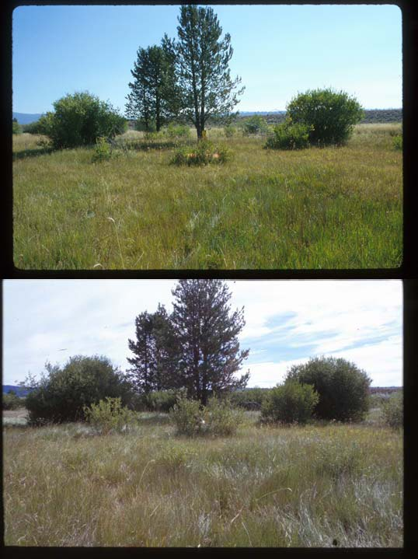
Willow
Year | Area (cm2)
2000 | 154458.9
2001 | 167867.8
2002 | 164466.7
2003 | 178837.3
2005 | 265014.7

2005
Stream temperatures have been monitored by the Tribe in Logan Valley since year 2000. Streams in Logan Valley are listed as water quality limited by the Oregon Department of Environmental Quality due to excessive temperature. Fish managers in the local area closely monitor temperatures from July 15 to August 15 where typically maximum stream temperatures occur and impact salmonids. To date, there is no significant decrease stream temperature due to management (Figures 7, 8 and 9). This is expected due to heavy grazing practices prior to acquisition resulted in a very low density of streamside hardwoods. In the past 5 years, they valley has displayed its resiliency as a fair density of willow have emerged, yet most are less than a meter tall and provide no additional cover and diversity to the aquatic habitats.

 | 2000 | 2001 | 2002 | 2003 | 2004 | 2005
Lake Creek  RK 4 | 17.44 | 16.88 | 16.69 | 17.54 | 18.04 | 17.90
Lake Creek  RK 0.5 | 18.80 | NA | 17.59 | 18.99 | 18.91 | 19.27
Malheur River  RK 389 | 15.24 | 14.21 | 14.96 | 15.99 | 15.11 | 15.31
Big Creek  RK 0.7 | 14.06 | 13.52 | 14.01 | NA | NA | 14.48
Big Creek  RK 3.7 | 12.48 | 10.79 | NA | 13.24 | NA | 12.86
Figure 7. Annual Water Temperature Averages for Logan Valley Streams in Oregon from 2000 through 2005. Annual Water Temperature Average is the average of the daily averages for the critical period (July 15 to August 15).

 | 2000 | 2001 | 2002 | 2003 | 2004 | 2005
Lake Creek  RK 4 | 23.75 | 22.79 | 22.87 | 22.11 | 23.31 | 23.77
Lake Creek  RK 0.5 | 24.27 | NA | 22.80 | 24.11 | 23.84 | 25.10
Malheur River  RK 389 | 20.84 | 19.03 | 20.54 | 21.01 | 19.91 | 20.53
Big Creek  RK 0.7 | 19.40 | 18.66 | 19.53 | NA | NA | 19.62
Big Creek  RK 3.7 | 16.96 | 15.03 | NA | 17.49 | NA | 17.39
Figure 8. Annual Water Temperature Maximums for Logan Valley Streams in Oregon from 2000 through 2005. Annual Water Temperature Maximum is an average of the daily maximum temperatures recorded through the critical period (July 15 to August 15).

 | 2000 | 2001 | 2002 | 2003 | 2004 | 2005
Lake Creek  RK 4 | 11.13 | 10.97 | 10.50 | 12.97 | 12.76 | 12.02
Lake Creek  RK 0.5 | 13.32 | NA | 12.39 | 13.68 | 13.98 | 13.45
Malheur River  RK 389 | 9.63 | 9.38 | 9.38 | 10.96 | 10.32 | 10.09
Big Creek  RK 0.7 | 8.72 | 8.38 | 8.50 | NA | NA | 9.36
Big Creek  RK 3.7 | 8.01 | 6.55 | NA | 9.0 | NA | 8.34
Figure 9. Annual Water Temperature Minimums for Logan Valley Streams in Oregon from 2000 through 2005. Annual Water Temperature Minimum is an average of the daily minimum temperatures recorded through the critical period (July 15 to August 15).

The ISRP has inquired on how each of the objectives and their associated work elements will be used. Some probabilistic sampling is proposed; however, more details about the proposed plan for a development of a monitoring and evaluation plan are necessary. Specifically, what will be monitored, what type of evaluation is proposed, and what adaptive management strategies may result?

Biological Objective #1 – Mitigate for the loss of anadromous fish species in the Malheur Subbasin through substitution programs that emphasize the long-term sustainability of native resident fish in native habitats wherever possible.

Work Element Name: Produce Inventory or Assessment
This work element proposes to build upon The Malheur River Subbasin Assessment and Management Plan (The Subbasin Plan). The Subbasin Plan has identified the need for additional redband trout data to better understand restoration and protection needs. Currently, redband trout are found in 76 streams in the Malheur River Subbasin and are managed as unique population units due to the lack of basic biological information. The proposal shall collect abundance, habitat, and genetic data to determine larger interactive groups or metapopulations, commonly referred to as conservation units. The project proposes to determine the population status, genetic integrity and identify habitat risks that threaten these larger conservation management units. The project shall seek to address the question of: 1) how large are populations; 2) how functional is the habitat for these populations; 3) how do site-specific environmental conditions affect population strengths and weaknesses; 5) how interconnected are the populations; and 6) how genetically pure are populations? Current restoration and protection prioritization actions identified in the Malheur River Subbasin Assessment and Management Plan can be expanded upon to better direct future proposed work for redband trout in the Subbasin.

Work Element Name: Produce Plan
Work Element Description/Methodology: This plan involves a systematic approach to monitor fish populations and population trend throughout the Malheur River Subbasin. A total of 180 sites will be sampled in 2007 and will be used as the baseline population for native fish. The plan will identify 36 sites distributed across the Subbasin that will be sampled annually. In a 5 year period, all 180 sites would have been sampled and the cycle will begin again. The Malheur Subbasin is an arid environment and fish populations are assumed to be very sensitive to environmental conditions and fluctuate greatly with snowpack and annual precipitation amounts. Due to the sensitivity to environmental conditions, we anticipate a general trend by sampling 36 sites annually. The Oregon Department of Fish and Wildlife has great interest in this monitoring approach. Based on conversations with the district biologist, a sample size of 180 sites is effective for estimating population size and trend yet is economically feasible that would attract participation from other local land management entities. The Oregon Department of Fish and Wildlife has expressed interest in maintaining 180 sites for population fish trend data from all 180 sites but lacks the staff and budget, and would need assistance from the Tribe and other entities such as US Forest Service and Bureau of Land Management. The Tribe proposes to maintain those sites associated with the ongoing Wildlife Mitigation projects, Logan Valley Wildlife Mitigation Site (project no. 200000900) and Malheur River Mitigation Site (project no. 200002700). These projects protect large tracts of land and have great fisheries benefits through riparian restoration and protection efforts. The Tribe proposes to adopt these monitoring sites to evaluate the effectiveness of the projects actions has on fish populations.

Annual bull trout redd surveys will be included in this long term monitoring plan. Methods and sample areas are currently well established and annual methods and results have been well documented in our annual reports since FY 1999. This data has been an excellent utility for fisheries managers and economically favorable in monitoring an ESA species.

Work Element Name: Coordination
There are many qualified state and federal fishery professionals in the Subbasin that have great knowledge of the local area. A coordination effort with state and federal entities shall provide technical review of the redband trout assessment that shall be recommended as an amendment to the current Subbasin Plan. Agency participation is needed for long term implementation of the population monitoring plan. Coordinate with the agencies to combine resources for long term monitoring.

Biological Objective #2 – Determine the population status and distribution of native salmonids, redband trout in particular, and develop a draft monitoring and evaluation plan for population trend in the Malheur River Subbasin utilizing approximately 180 reference sites.

Work Element Name: Collect/Generate/Validate Field and Lab Data
Collect the baseline population data at all 180 sites.

Work Element Name: Develop RM&E Methods and Designs
Once data collection is completed on all 180 sites, develop a 36 site annual rotation schedule for population trend. The Tribe will work closely with the Oregon Department of Fish and Wildlife in developing this draft plan. This document will include site location, estimated sample time, estimated costs, and annual sampling schedule. The draft will be provided to other local entities for their review.

Work Element Name: Collect/Generate/Validate Field and Lab Data
The Tribe proposes to initiate the first two years of monitoring in the Malheur River Subbasin that consists of 36 sites annually.

Biological Objective #3 - Develop a draft monitoring and evaluation plan for bull trout population trend in the Malheur River Subbasin utilizing redd count surveys on approximately 36 miles of stream.

Work Element Name: Collect/Generate/Validate Field and Lab Data
Continue to fund Tribal participation in the annual bull trout redd surveys conducted in the North Fork and upper Malheur River Watersheds.

Work Element Name: Develop RM&E Methods and Designs
Include spawning survey methods, schedule, sampling time, and cost in the draft Monitoring Plan for agency review.

Biological Objective #4 – Quantify stream habitat attributes at a total of 30 monitoring sites that sustain low, medium, and high densities of native salmonids species.

Work Element Name: Collect/Generate/Validate Field and Lab Data
Use of detailed habitat unit data and GIS data overlays such as road density, diversion points, and land use shall provide the knowledge of site specific conditions as well as watershed-level characteristics that both explain patterns of fish distribution and abundance and provide information for habitat improvement actions.

Biological Objective #5 – Determine the population integrity and rates of introgression/hybridization for 56 redband trout populations.
Work Element Name: Collect/Generate/Validate Field and Lab Data
The ISRP is seeking for the sponsor to justification for the number of sites to be sampled and the number of fish used in the genetic work. The project sponsor has consulted with US Fish and Wildlife Service Abernathy Fish Technology Center (AFTC) on this issue. ODFW has identified 76 streams with redband trout and manage these populations as distinct populations (Hanson et al. 1990). Sampling 76 populations is very labor intensive considering obvious connectivity between many streams. In our discussion with AFTC, we opted to lump those streams that are known to have good habitat connectivity, especially in areas with good water quality and flow. We mapped the streams confluence on GIS and where able to determine “clusters” (Figure 10). These clusters were identified and are assumed distinct populations. A total of 44 populations have been identified. AFTC noted that if divergence is detected through the genetic analysis, it will be recommended that additional samples be taken from the identified area.

A total of 10 sample units approximately 100 meters in stream length per population will be sampled. A maximum of 4 samples per unit will be taken. Total stream length will be determined on GIS and sampling sites evenly dispersed throughout the assumed population. If a minimum of 30 cannot be obtained through ten sites, twenty sites will be identified and sampled until the minimum criterion is met.

Work Element Name: Collect/Generate/Validate Field and Lab Data
Abernathy Fish Technology Center is the proposed geneticist for the redband samples collected in the Malheur River.

The ISRP is inquiring on how the results of the project are shared. To date, we send our annual report to: Oregon Department of Fish and Wildlife Hines, Oregon and Ontario, Oregon; US Fish and Wildlife Service La Grande, Oregon; US Bureau of Land Management Vale, Oregon; US Forest Service Prairie City, Oregon; and US Bureau of Reclamation Boise, ID. Data is provided upon request. Project results are presented for professional workgroups and at public meeting at watershed councils. Project results are presented to the Tribal Council and General Council of the Tribe annually. Given the current technology, the project sponsor proposes that annual reports will be distributed with a data CD.

Data is stored at Tribal offices and is available upon request. We are looking at purchasing a file storage server with tape backup capacity for growth. The procedure, for now will be a full daily backup on tape and the Thursday tape will be stored in our off site bank safe deposit box. The project sponsor has been working with the current BPA COTR on where to publicly store project data but has not yet been identified. Staff is aware of ISRP concerns with the availability of data throughout the region and their recommendation for a data management center to better distribute information. Staff is willing to forward data and welcome recommendations.

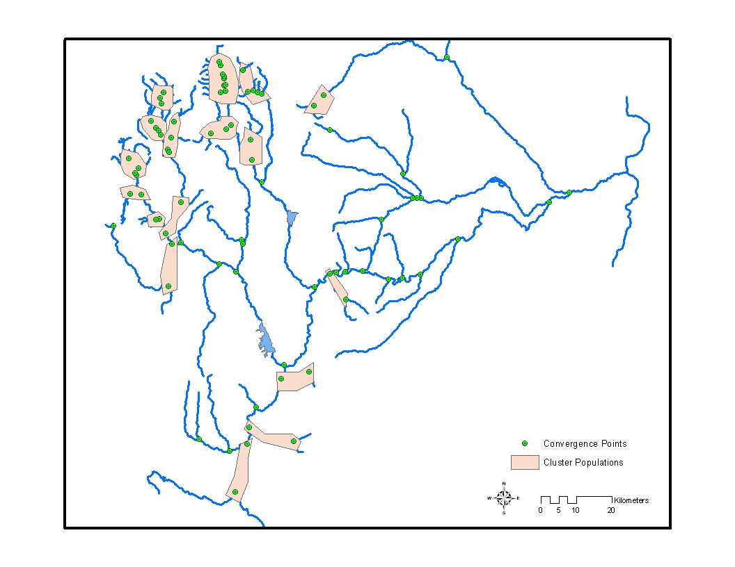

Figure 10.
Clusters of redband trout populations identified in the Malheur River Basin.

References

Boyd, C. S. and T. J. Svejcar. 2005. A Visual Obstruction Technique for Photo Monitoring of Willow Clumps. Rangeland Ecology Management 58:434 -438

Boyd, C. and J. Zamora. 2005. Final Report on Research Activities in Logan Valley.
Eastern Oregon agricultural Research Center. United States Department of Agriculture. Burns, Oregon.

BPT 2004. Reestablishing Vital Bull Trout Habitat in the Headwaters of the Malheur
River Through the Use of Willow Reestablishment. U.S. Fish and Wildlife Service Bend Field Office. Project Agreement Number: 13420-1-J136.

Fenton, J., L. Schwabe, W. Lipe, and R. Perkins. 2006. 2005 Annual Report.
“Evaluation of the Life history of Native Salmonids in the Malheur Subbasin: Project No. 1997-01900.In Press.

Schwabe, L., M. Tiley, R. Perkins, D. Gonzalez, W. Bowers, R. Rieber, A. Mauer, S. Bush, C. Tait. 2000. 1999-2000 Annual Report. “Evaluation of the Life history of Native Salmonids in the Malheur River Basin: Project No. 1997-01900, 120 electronic pages, (BPA Report DOE/BP-00006313-1)
Schwabe, L., S. Namitz, J. Fenton, R. Perkins, P. Spruell, D. Gonzalez, J. Wenick, W. Bowers, R. Rieber, A. Mauer, S. Bush, C. Tait. 2001. 2000-2001 Annual Report. “Evaluation of the Life history of Native Salmonids in the Malheur River Basin: Project No. 1997-01900, 189 electronic pages, (BPA Report DOE/BP-00006313-2)
Schwabe, L., J. Fenton, R. Perkins, J. Wenick, T. Walters, W. Bowers, R. Rieber, A. Mauer, A. Miller, J. Soupir, C. Tait. 2002. 2001-2002 Annual Report. “Evaluation of the Life history of Native Salmonids in the Malheur River Basin: Project No. 1997-01900, 143 electronic pages, (BPA Report DOE/BP-00006313-3)
Schwabe, L., S., J. Fenton, K. Fenn, and R. Perkins. 2004. 2003 Annual Report. “Evaluation of the Life history of Native Salmonids in the Malheur Subbasin: Project No. 1997-01900.

